DATE: **March 8, 2021**

TO: **Dr. Deirdre Hunter**

FROM: **Sindhuja Darisipudi, Nora Han, Joseph Urso, Michael Tang, Jason Ye[1]**

**Team Moonrats (**[**5moonrats@gmail.com**](mailto:5moonrats@gmail.com)**)**

SUBJECT: **Screening, Scoring and Selection of Water Assessment Incubator Solution**

**Screening, Scoring and Selection Overview**

Our team is designing a portable incubator to provide a stable temperature environment for 3M™ E. coli detection Petrifilms[2]. We evaluated our brainstormed solutions and have combined them into several complete solutions.. Figure 1 represents a flowchart of our selection process.

Our design includes many intricate parts, so we brainstormed ideas for each design block. Our design blocks included data logging, digital display, heating, insulation, power source, and the shape of the design. Because we split up the design in this manner, we formed many partial/component solutions. After brainstorming solutions, we combined the ideas into a Morph Chart (Figure 2). Upon further examination, we identified that our Morph Chart had too many options. At this point, we decided to screen our design block solutions against the design criteria. Our goal was to have ≤ 5 options for each design block. Therefore, we decided to screen all design blocks with > 5 solution options. We created a screening matrix for heating, insulation, and shape/form. These screening matrices can be seen respectively in Figure 3, Figure 4, and Figure 5. After narrowing our options for each design block, we created a final Morph Chart (Figure 6). Using the final morph chart, each member of our group created 2-3 complete solutions.

After creating complete solutions, we took turns and explained our solutions to one another. We wanted each member to fully understand each solution that was to be scored. Once we were all on the same page, we proceeded to score them against each other (Figure 7). In total, we scored 11 solutions. We created a proxy for battery duration, ease of fabrication, and durability. All details regarding proxies and scales used for scoring can be found in Figure 8 and in the section “Proxies for Scoring”.

After scoring, we selected our top 4 scoring solutions and identified popular components amongst the high scoring solutions. By identifying popular components, we wanted to identify which items seemed “most reliable” or “important to the design”, and attempted to include these within our final design. Ultimately, we chose to move forward with solution I. We believe solution I was the most feasible of all our top solutions. Solution I requires one fabricated part and the remainder of parts can be ordered online. Additionally, its cost is average and a thermos would be smaller than the existing solution. Finally, the insulation method is extremely efficient (vacuum insulation) and this would result in lower power consumption in order to maintain temperature within our design. The battery and control system will be located at the bottom of the device. There will be a separate mechanism for holding the Petrifilms. We will wrap heating tape around the inside layer of our Thermos. Figure 9 is a preview of our selected design.

**Proxies for Scoring**

Our proxy for battery duration is based on an imaginary parameter called “electricity score”. This score is based on the number of components that will require power. Additionally, we take into account the effects of insulation. A better insulator will require that we use less power, so a better insulator will subtract 1 from the electricity score. A worse insulator will add 1 to the electricity score. The distinction between “better” or “worse” insulators was decided in our insulation screening matrix. More information on “best insulator” can be found in Figure 4.

Our proxy for ease of fabrication is based on the number of fabricated parts. Below is a list of what is considered a fabricated part:

* Having to fasten/attach battery to a surface
  + Rather than placing it inside
* Having to fasten/attach heating element to a surface
  + Ex: Taping/gluing/screwing in heating pad to a surface
* Modifying foam, reflective insulation bags, or wood wool to fit into device
* Modifying outer shell for place to put the digital display
* Implementing a emergency battery pack to function after main power source is low
* Implementing a light indicator
* Structured foldable structure or rollable insulation bag
* Creating/implementing supports for foldable structure or insulation bag
* Creating casing/mechanism for holding perti-films or moving them in and out of device

Our proxy for durability is dependent on the number of “weak” components. A weak component is a component that is easily damaged or will have to be replaced regularly (approximately 3-6 months). We add 1 to the score for each weak component. The list of weak components include:

* OLED/LED or LCD Screen
* Heating Pad
* Soft outer case

**Results of Screening, Scoring, and Selection**

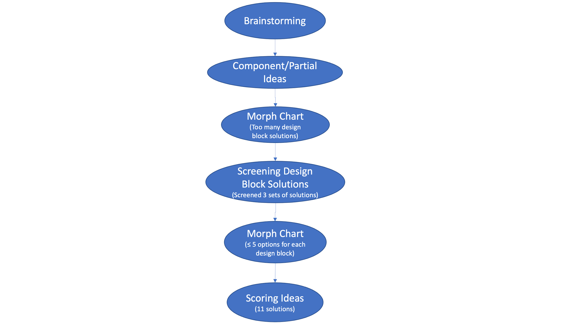

***Figure 1: Flow Chart for Our Selection Process (missing)***

| **Design Blocks** | Option 1 | Option 2 | Option 3 | Option 4 | Option 5 | Option 6 | Option 7 | Option 8 |
| --- | --- | --- | --- | --- | --- | --- | --- | --- |
| Data Logging | Light indicator | Bluetooth to smartphone | Built in Smartphone | Digital thermometer | Serial Port |  |  |  |
| Digital Display | OLED Screen | LCD Screen | Live Data Display | Battery % represented | None |  |  |  |
| Heating | Heating Pad | Heating by liquid | Heating coil | Heat tape | Capturing energy from outside environment | use lens to focus sunlight |  |  |
| Insulation | Packing styrofoam | Reflective insulation bags | Vacuum Sealing Insulator | Packing Peanuts | Yeti Cup Casing | Bubblewrap | Nomex | Wood wool |
| Power Source | Rechargeable (car adapter) | Rechargeable battery (AC adapter) | Disposable battery pack (AA or D) | Easily removable battery pack | Emergency battery pack |  |  |  |
| Shape/Form | Rollable insulation bag (tri-prism) | Structured foldable structure | Cylindrical (Thermos or Yeti Cup) | rectangular prism | Sphere | Collapsible structure |  |  |

***Figure 2: Initial Morph Chart***

Note: We did not use this Morph Chart to generate solutions. Upon examination, we thought this Morph Chart had too many solutions for certain design blocks.

|  | Heating Pad | Heating by liquid | Heating coil | Heat tape | Capturing energy from outside environment | Use lens to focus sunlight | Lightbulb |
| --- | --- | --- | --- | --- | --- | --- | --- |
| Cost | 0 | -1 | -1 | 0 | -1 | 1 | 1 |
| Size | 0 | -1 | 0 | 1 | 0 | 0 | -1 |
| Ease of Fabrication | 0 | -1 | 0 | -1 | -1 | -1 | -1 |
| Durability | 0 | -1 | 1 | 1 | 0 | -1 | -1 |
| Battery Duration | 0 | -1 | 0 | 0 | 1 | 1 | -1 |
| **TOTAL** | **0** | **-5** | **0** | **1** | **-1** | **0** | **-3** |

***Figure 3: Screening Matrix for Heating Methods***

Note: Solutions that made it to the final Morph Chart are highlighted in grey.

|  | Packing styrofoam | Reflective Insulation Bags | Packing Peanuts | Yeti Cup Casing | Bubblewrap | Nomex | Wood wool | Foam | Cooler | Fiberglass |
| --- | --- | --- | --- | --- | --- | --- | --- | --- | --- | --- |
| Cost | 0 | 0 | 0 | -1 | 0 | -1 | 0 | 0 | -1 | -1 |
| Size | -1 | 1 | -1 | 1 | 0 | 1 | -1 | 0 | 0 | 0 |
| Ease of Fabrication | 0 | 0 | 0 | 1 | 0 | 0 | 0 | 0 | 1 | 0 |
| Durability | -1 | 1 | -1 | 1 | -1 | 0 | -1 | 0 | 1 | 1 |
| Battery Duration | 0 | -1 | 0 | 1 | -1 | -1 | -1 | 0 | 1 | -1 |
| **TOTAL** | **-2** | **1** | **-2** | **3** | **-2** | **-1** | **-3** | **0** | **2** | **-1** |

***Figure 4: Screening Matrix for Insulation Methods***

When comparing each solution against battery duration, we considered the quality of each insulator. The quality of the insulator is dependent on its thermal conductivity.

|  | Rollable Insulation Bag (Tri-Prism) | Structured Foldable Structure | Cylindrical (Thermos or Yeti Cup) | Rectangular Prism (Cooler) | Sphere | Collapsible Structure |
| --- | --- | --- | --- | --- | --- | --- |
| Cost | 1 | 1 | 0 | 0 | -1 | 0 |
| Size | 1 | 1 | 1 | 0 | 1 | 1 |
| Ease of Fabrication | -1 | 1 | 1 | 0 | -1 | -1 |
| Durability | -1 | -1 | 0 | 0 | -1 | -1 |
| Battery Duration | 0 | 0 | 0 | 0 | 0 | 0 |
| **TOTAL** | **0** | **2** | **2** | **0** | **-2** | **-1** |

***Figure 5: Screening Matrix for Shape of our Design***

For this set of solutions, battery duration is unrelated to the shape of the design. Therefore, a 0 was put in place for all solutions.

| **Design Blocks** | Option 1 | Option 2 | Option 3 | Option 4 | Option 5 |
| --- | --- | --- | --- | --- | --- |
| **Data Logging** | Light indicator | Bluetooth to smartphone | Built in smartphone | Digital thermometer | Serial Port |
| **Digital Display** | OLED Screen | LCD Screen | Live data display | Battery % represented | None |
| **Heating** | Heating Pad | Heating coil | Heat tape |  |  |
| **Insulation** | Cooler | Reflective insulation bags | Foam | Fiberglass | Yeti Cup Casing |
| **Battery** | Rechargeable (car adapter) | Rechargeable battery  (AC adapter) | Disposable battery pack (AA or D) | easily removable battery pack | Emergency battery pack |
| **Shape** | Rollable insulation bag (tri-prism) | Structured foldable structure | Cylindrical  (Thermos or Yeti Cup) | rectangular prism |  |

***Figure 6: Final Morph Chart***

| **Design Criteria** | **Weight** | **Solution A** | | **Solution B** | | **Solution C** | | **Solution D** | | **Solution E** | |
| --- | --- | --- | --- | --- | --- | --- | --- | --- | --- | --- | --- |
| **Rating** | **Weight Score** | **Rating** | **Weight Score** | **Rating** | **Weight Score** | **Rating** | **Weight Score** | **Rating** | **Weight Score** |
| **Size** | 30% | 1 | 0.3 | 2 | 0.6 | 1 | 0.3 | 2 | 0.6 | 1 | 0.3 |
| **Battery Duration** | 30% | 5 | 1.5 | 3 | 0.9 | 4 | 1.2 | 3 | 0.9 | 4 | 1.2 |
| **Ease of Fabrication** | 20% | 3 | 0.6 | 4 | 0.8 | 3 | 0.6 | 2 | 0.4 | 4 | 0.8 |
| **Durability** | 10% | 4 | 0.4 | 4 | 0.4 | 4 | 0.4 | 4 | 0.4 | 4 | 0.4 |
| **Cost** | 10% | 4 | 0.4 | 3 | 0.3 | 3 | 0.3 | 2 | 0.2 | 1 | 0.1 |
| TOTAL |  |  | 3.2 |  | 3 |  | 2.8 |  | 2.5 |  | 2.8 |

| **Design Criteria** | **Weight** | **Solution F** | | **Solution G** | | **Solution H** | | **Solution I** | | **Solution J** | | **Solution K** | |
| --- | --- | --- | --- | --- | --- | --- | --- | --- | --- | --- | --- | --- | --- |
| **Rating** | **Weight Score** | **Rating** | **Weight Score** | **Rating** | **Weight Score** | **Rating** | **Weight Score** | **Rating** | **Weight Score** | **Rating** | **Weight Score** |
| **Size** | 30% | 4 | 1.2 | 4 | 1.2 | 3 | 0.9 | 2 | 0.6 | 1 | 0.3 | 5 | 1.5 |
| **Battery Duration** | 30% | 2 | 0.6 | 2 | 0.6 | 4 | 1.2 | 5 | 1.5 | 5 | 1.5 | 2 | 0.6 |
| **Ease of Fabrication** | 20% | 1 | 0.2 | 1 | 0.2 | 2 | 0.4 | 5 | 1 | 4 | 0.8 | 3 | 0.6 |
| **Durability** | 10% | 2 | 0.2 | 2 | 0.2 | 4 | 0.4 | 5 | 0.5 | 3 | 0.3 | 2 | 0.2 |
| **Cost** | 10% | 3 | 0.3 | 2 | 0.2 | 1 | 0.1 | 3 | 0.3 | 5 | 0.5 | 5 | 0.5 |
| **TOTAL** |  |  | **2.5** |  | **2.4** |  | **3** |  | **3.9** |  | **3.4** |  | **3.4** |

***Figure 7: Scoring Matrix***

Solutions highlighted in gray were our four highest scoring solutions.

| **Design Criteria** | **Proxy** | **Scoring Matrix Ranking** |
| --- | --- | --- |
| Battery Duration | Electricity Score (ES = Electricity Score) (see explanation above) | 5: ES = 1 |
| 4: ES = 2 |
| 3: ES = 3 |
| 2: ES = 4 |
| 1: ES ≥ 5 |
| Ease of Fabrication | # of fabricated parts (see above for what is considered a “fabricated part”) | 5: 1 part |
| 4: 2 parts |
| 3: 3 parts |
| 2: 4 parts |
| 1: ≥ 5 parts |
| Durability | Based on # of weak components (see above for “weak components”) | 5: 0 weak components |
| 4: 1 weak component |
| 3: 2 weak components |
| 2: 3 weak components |
| 1: ≥ 4 weak components |
| Cost | N/A | 5: ≤ $100 |
| 4: $100 - $115 |
| 3: $115 - $130 |
| 2: $130 - $145 |
| 1: ≥ $145 |
| Size | N/A | 5: ≤ 200 cubic inches |
| 4: 400 - 200 cubic inches |
| 3: 600 - 400 cubic inches |
| 2: 2000 - 600 cubic inches |
| 1: ≥ 2000 cubic inches |

***Figure 8: List of Scales and Proxies Used in Scoring***

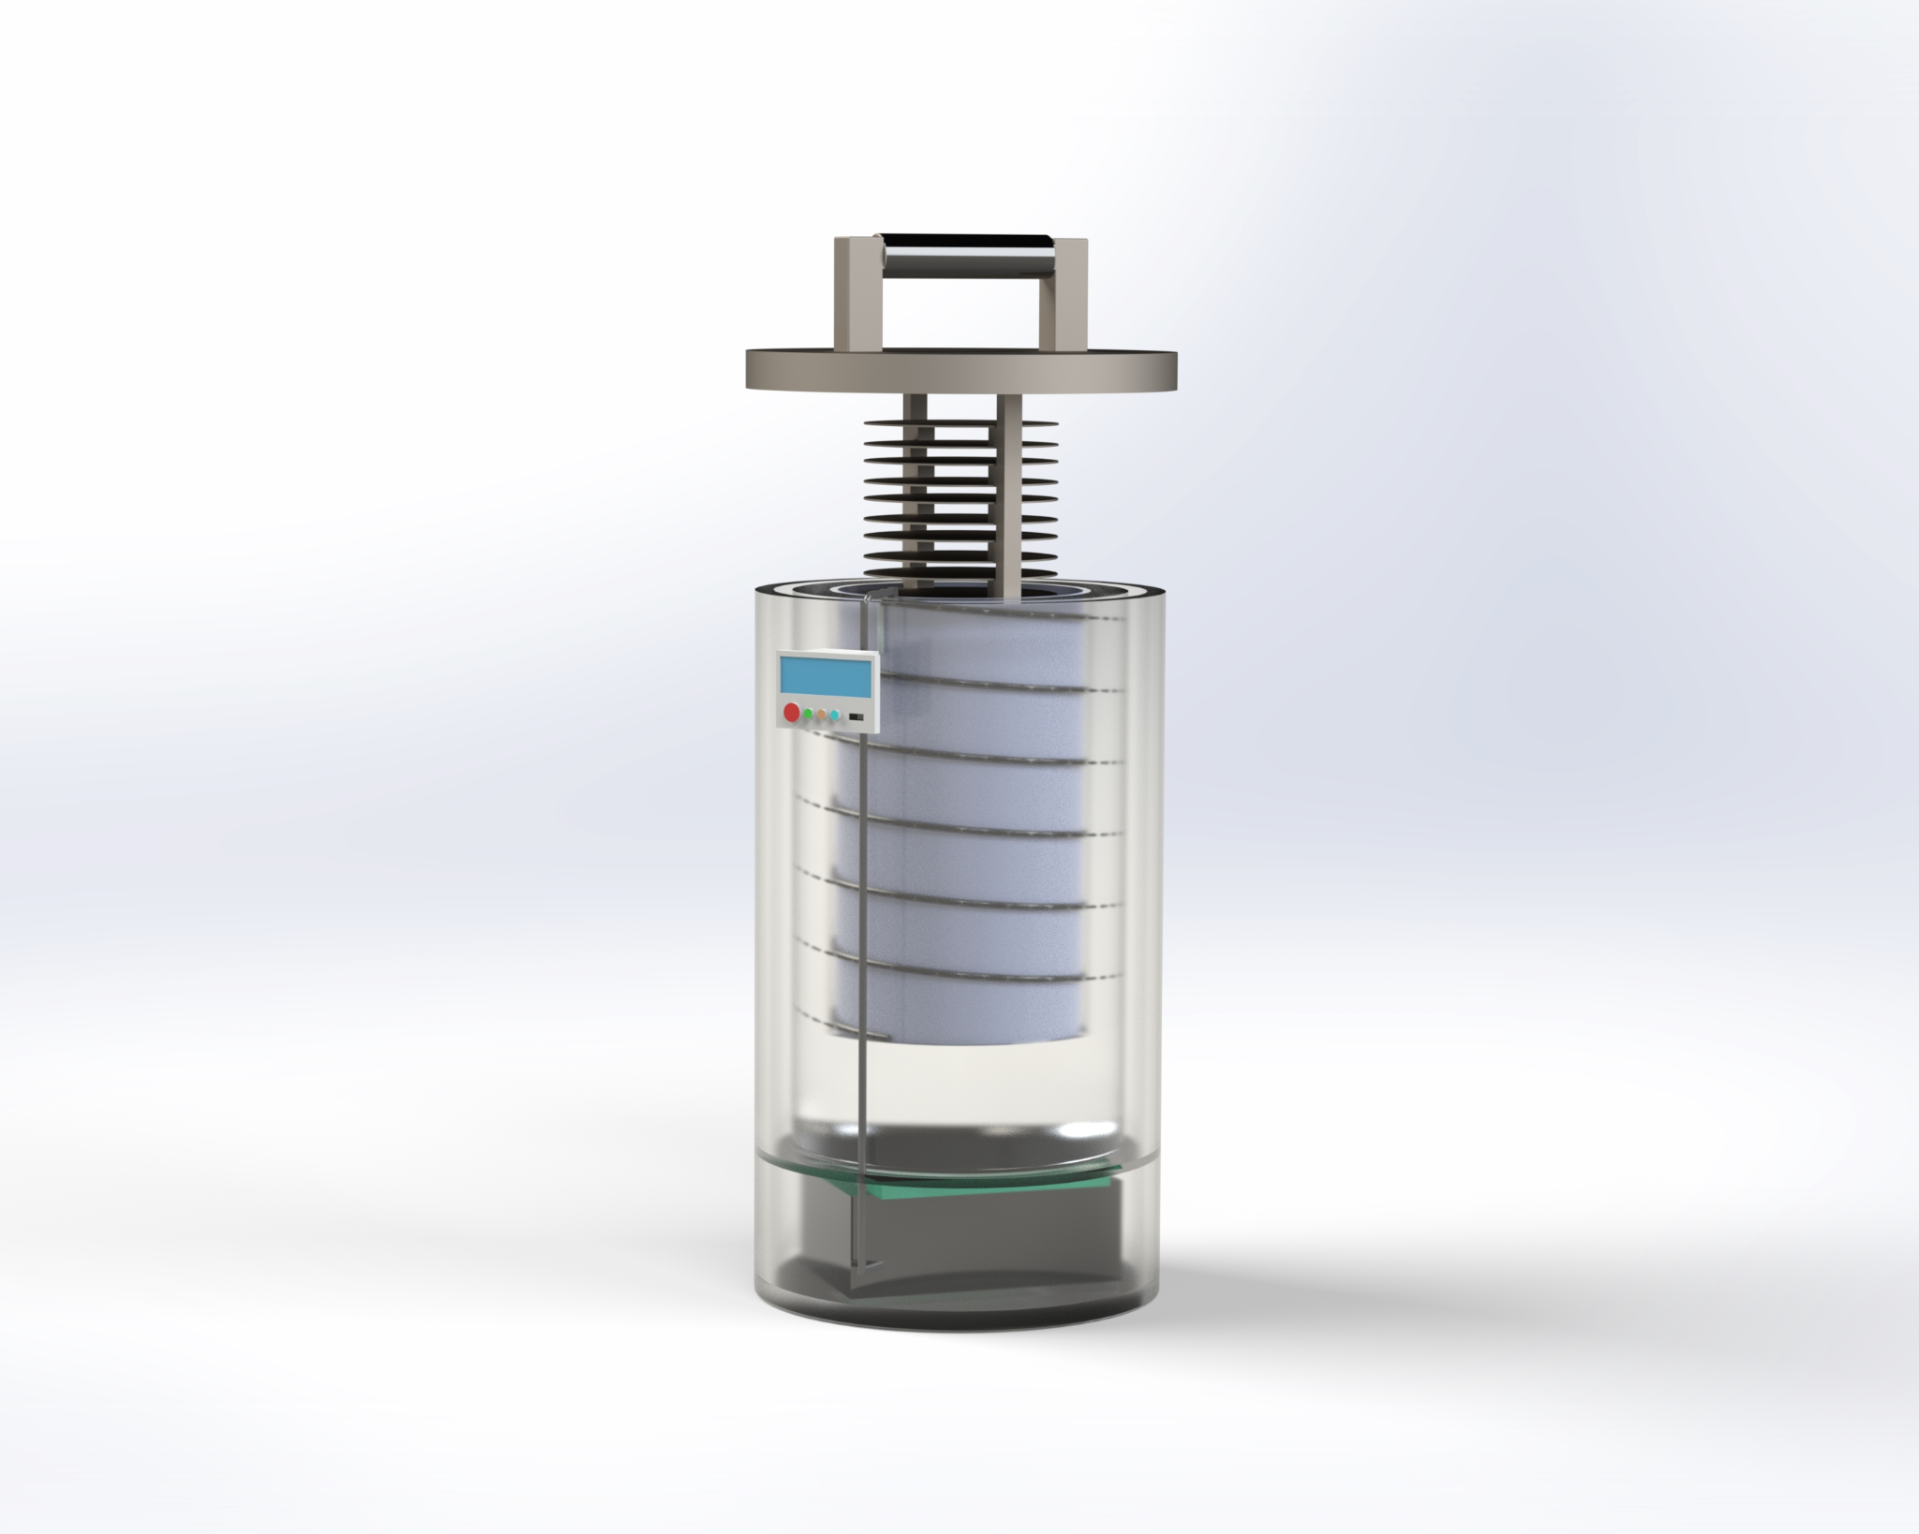

***Figure 9: Preview of our Selected Solution***

**Conclusion**

**1. What were key features that helped distinguished between solutions?**

We believe that the most important feature of the selected solution is the form factor, which is the combination of insulation and shape as we choose to use a thermos. Although thermos don’t score high in size, its vacuum insulation is very effective in saving energy. Moreover, although our major mission in this project is to reduce the size of the incubator, the solutions that score the highest in size (foldable structures and rollable structures) have rather poor insulation and potential durability problems. We think that for the above two transformable structures, everything has to be thin enough so that the users can transform them easily and without damaging crucial parts, such as the insulating material. Folding or rolling a thick piece of foam may cause damage to the foam, and as a result will affect insulation effectiveness, which can cause higher energy emission that leads to a higher energy consumption from the battery.

Another concern with foldable and rollable structures is that comparing to rigid form factors, these two structures provide weaker support and protection for other parts, especially battery and control board, under severe working conditions. The incubator needs to work in the testing site, which typically is in the wild by the river, so it is important for it to be water-proof, but it’s much harder to seal transformable structures tight than rigid structures. Also, the incubator will most likely to be transported in the back of a truck, so the whole body needs to be strong enough to protect important parts from bumpings and collisions. We think that rigid shells do much better than soft shells in that.

In conclusion, for the form factor part, considering both insulation ability and strength of the structure, we think that a thermos is the best choice.

**2. What features of your process heavily influenced solution selection?**

The quantified 1-5 values heavily influenced our solution selection. Take battery duration in our scoring matrix as an example. We conclude that battery duration is mainly decided by three factors: the number of electric components it has to power, the effectiveness of insulation (because better insulation prevents energy emission, which saves power), and whether there will possibly be space for extra battery. We define the raw score of battery duration by adding the number of electric components it needs to power, plus one if the insulation method of that solution is poor, minus one if the insulation is good, and finally minus one if there is extra space for back-up battery.

When deciding if the insulation is good or not in this section, we first analyze the Fourier’s Law for heat conduction, which states that the speed of heat transfer is directly proportional to the thermal conductivity of the material. Therefore, we should consider two factors: the thermal conductivity (the lower the better for insulation) of the insulating material and how thick the material can be in the solution. For example, for Yeti cup casing and thermos, the insulation is basically a vacuum, which theoretically has a thermal conductivity of 0, so it is definitely a good insulation method regardless of the thickness. For other materials such as Styrofoam, which has a thermal conductivity of 0.033, thickness has to be taken into consideration. In a rigid container such as a cooler, we can place very thick foam around the incubation chamber, so it’s also a good insulation. However, for rollable structures and foldable structures, we may not be able to fold or roll very thick foam, so they are considered poor insulation.

After calculating the raw scores, which range from 1-5, we transfer them into scores in the scoring matrix. A raw score of 1 corresponds to a 5 in the scoring matrix, and a raw score of 5 corresponds to a 1 in the scoring matrix.

For other design criteria in the scoring matrix, we use a similar approach. For durability, we estimate the number of design parts in the solution that are most likely to cause a reliability problem in severe working conditions. For ease of fabrication, we estimate the number of customized parts in each solution that may require special manufacturing processes or can only be ordered from manufacturers.

**3. What salient process decisions were made during solution selection?**

One of the salient decisions we made during scoring is that we decided to remove cooling system and the design criterion of adjustable temperature in screening and scoring after we meet with Dr. Read and reconsider the process of incubation. We initially wanted to include a cooling system because we imagined that the incubator would function as an air-conditioner for Petrifilms that could both increase and decrease the temperature during incubation. However, we realized that there can’t be a scenario which requires the incubator to decrease the temperature after the incubation starts. Therefore, we redefined “adjustable temperature” as to be able to set different incubation temperatures before the incubation. To this end, we believe that this function can be realized fully by programming, so it’s not necessary to include this in the scoring matrix which mainly decides the hardware of the incubator.

**4. What were the memorable moments or discussions that led to breakthroughs in process and/or products?**

One of the memorable moments is that the whole group and Scott had a 5-hour meeting from 8pm to 1am in the morning. Before this meeting, we were a bit behind schedule, but fortunately, we were able to sort so many things out during that meeting. Everyone participated in the discussion and was researching for supporting materials for screening and scoring. After this meeting, we felt so relieved because one of the most difficult parts of ENGI 120 has passed and we made it. Everything was back on track after that night. We were tired, but our group work finally produced dream work.

1. Main Writers: Joseph Urso and Jason Ye
2. See details at: https://www.3m.com/3M/en_US/company-us/all-3m-products/~/ECOLICT-3M-Petrifilm-E-coli-Coliform-Count-Plates/?N=5002385+3293785155&rt=rud